**Snippets of the testing for " Systems Programming "**

1) Success case which out puts the file list with disk usage.

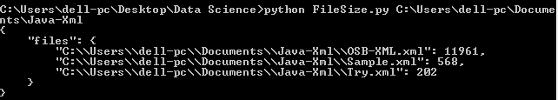

2) Gives error "**The** **entered directory does not exists**" If the entered directory does not exists.

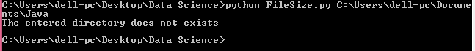

3) Gives error "**This is not a directory**" If the entered is not a directory .

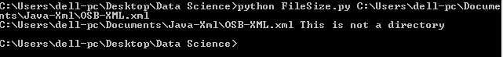

4) Complete snippet of the success and the error scenarios.

